**GITHUB LINK-** <https://github.com/prasant931/todo_list>

**Website link-** http://prasantpradeep.pythonanywhere.com/register/

**1) User Login:-**

* User can log in by entering their Username and password.

If not registered user , can click on register link below.

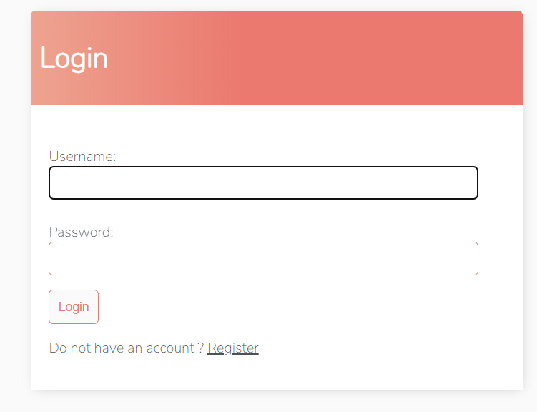

**2) User register:-**

* Register new account using User name, password.

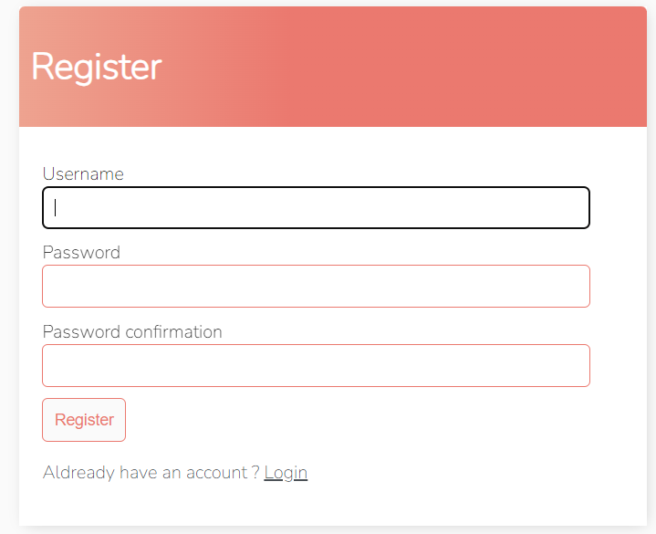

**3) To do list:-**

* Shows the name of user.
* Shows number of incomplete task.
* Shows tasks pending
* To edit a task click on the task name.
* To search a to do list by keyword, enter the name in search list box.
* To logout click on logout on right side.
* To add a new task click on + symbol to the right side of search box.

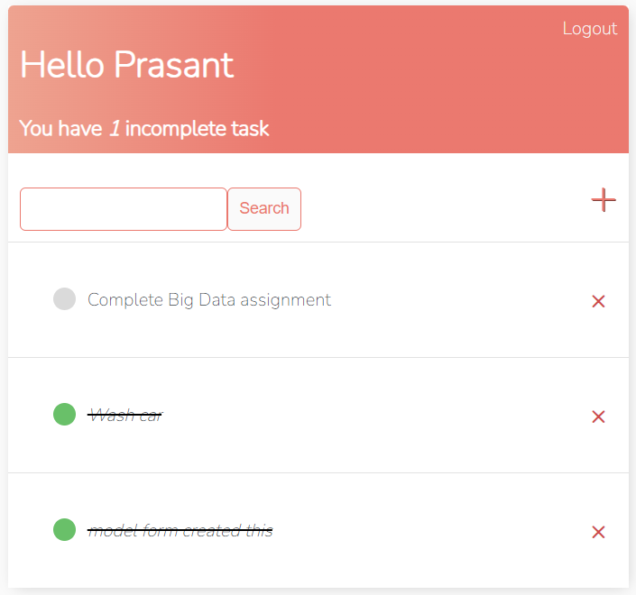

**4) Edit/New task :-**

* To edit a task click and task and redirected to the page given below.
* Edit/add title name , description , complete check box to identify if task is complete or not.

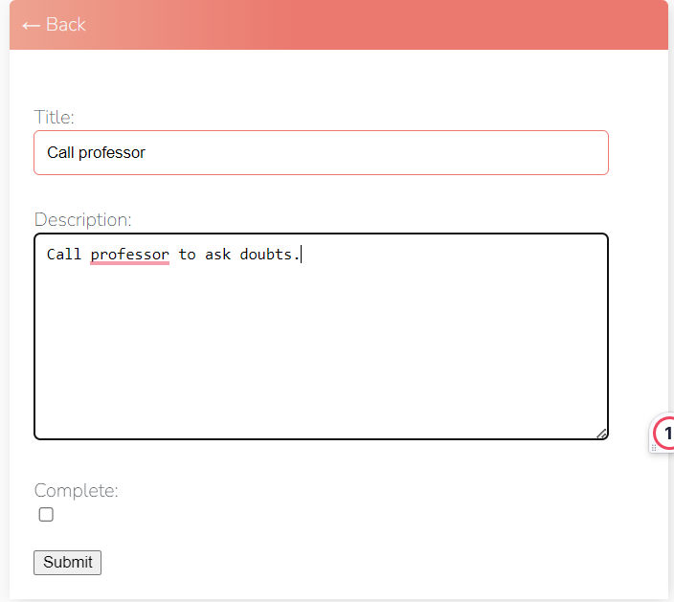

**5) Delete task:-**

* Click on the x symbol to delete.
* Redirected to a page to confirm task deletion.
* Click on Go Back to go to previous page.

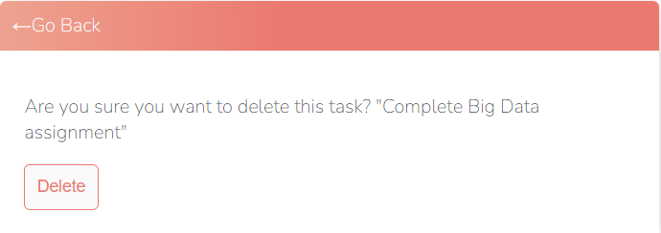

**BUILD:-**

* **Front-end Html/ CSS.**
* **Used Django.**
* **Language used Python.**
* **Built in database using SQLLite.**
* **Deployed using python anywhere.**